Introduction To Karpenter

Karpenter is an open-source, flexible, high-performance Kubernetes Cluster Autoscaler built with AWS. It helps improve your application availability and cluster efficiency by rapidly launching right-sized compute resources in response to changing application load. Karpenter also provides just-in-time compute resources to meet your application’s needs and will soon automatically optimize a cluster’s compute resource footprint to reduce costs and improve performance.

Before Karpenter, Kubernetes users needed to dynamically adjust the compute capacity of their clusters to support applications using [Amazon EC2 Auto Scaling groups](https://docs.aws.amazon.com/autoscaling/ec2/userguide/AutoScalingGroup.html) and the [Kubernetes Cluster Autoscaler](https://github.com/kubernetes/autoscaler/tree/master/cluster-autoscaler). Nearly half of Kubernetes customers on AWS report that configuring cluster auto-scaling using the Kubernetes Cluster Autoscaler is challenging and restrictive.

When Karpenter is installed in your cluster, Karpenter observes the aggregate resource requests of unscheduled pods and makes decisions to launch new nodes and terminate them to reduce scheduling latencies and infrastructure costs. Karpenter observes events within the Kubernetes cluster and sends commands to the underlying cloud provider’s compute service, such as Amazon EC2.

Karpenter is an open-source project licensed under the [Apache License 2.0](https://github.com/awslabs/karpenter/blob/main/LICENSE). It is designed to work with any Kubernetes cluster running in any environment, including all major cloud providers and on-premises environments. We welcome contributions to build additional cloud providers or to improve core project functionality. If you find a bug, have a suggestion, or have something to contribute, please engage with us on [GitHub](https://github.com/awslabs/karpenter/issues).

Below is a comprehensive explanation of Karpenter's key features and functionalities:

1. **Autoscaling for EKS Clusters:**

Karpenter streamlines the process of scaling EKS clusters by automatically managing the underlying infrastructure. It ensures that enough worker nodes (EC2 instances) are available to meet your Kubernetes workloads' demands. This autoscaling capability is crucial for handling varying workloads efficiently.

1. **Optimized Resource Provisioning:**

Karpenter optimizes the allocation of resources by considering factors such as application resource requests, limits, and constraints. This ensures that the suitable types and sizes of EC2 instances are provisioned based on the requirements of your applications, promoting cost-effectiveness.

1. **Integration with Cluster Autoscaler:**

Karpenter works seamlessly with the Cluster Autoscaler, another component of the Kubernetes ecosystem. The Cluster Autoscaler adjusts the size of the EKS node groups based on the pending pods in the cluster. Karpenter complements this by handling the provisioning of new nodes when needed.

1. **Customizable Policies:**

Users can define policies to customize Karpenter's behaviour according to their specific requirements. These policies may include constraints on instance types, regions, or other parameters. Customization allows users to align Karpenter with their organization's preferences and policies.

1. **Event-Driven Scaling:**

Karpenter employs an event-driven architecture that responds to triggers and events in the EKS cluster. For example, if there are pending pods waiting to be scheduled and the existing nodes are insufficient, Karpenter will automatically initiate the provisioning of additional nodes.

1. **Support for Spot Instances:**

Karpenter supports using Spot Instances, which includes spare EC2 instances available at a lower cost. By integrating with Spot Instances, Karpenter helps optimize infrastructure costs for EKS clusters, making it an attractive option for cost-conscious users.

1. **Easy Installation and Management:**

Setting up Karpenter for an EKS cluster is designed to be straightforward. AWS provides documentation and resources to guide users through the installation and configuration process. Once set up, Karpenter operates autonomously, reducing the operational burden on users.

1. **Community and Open Source:**

Karpenter is part of the open-source community and is actively developed and maintained. The community-driven nature of the project encourages collaboration and contributions from users, ensuring ongoing improvements and updates.

Below is a diagrammatic representation of Karpenter in use

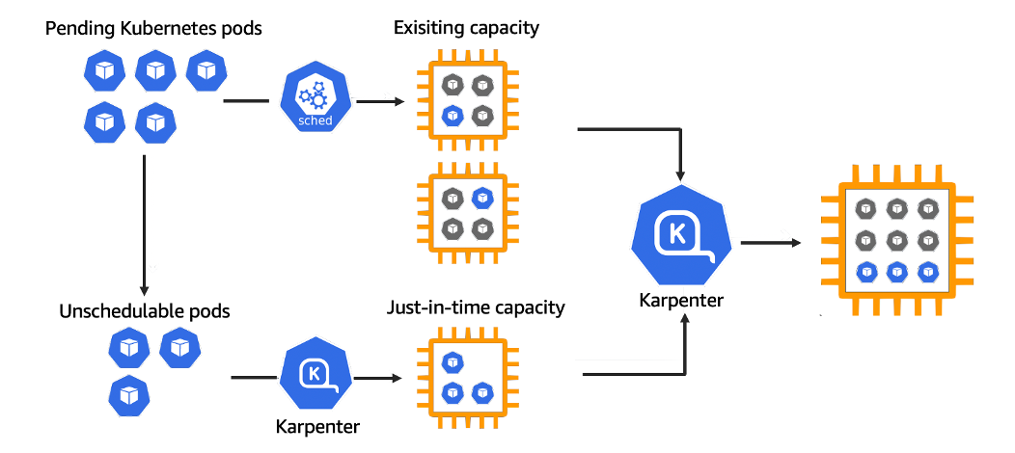

**Installation of Karpenter for production use**

To install Karpenter for production use, you typically follow the steps to configure and deploy it in your Amazon EKS (Elastic Kubernetes Service) cluster on AWS. Be informed that the exact steps may vary based on updates and changes, so it's recommended to refer to the official AWS documentation for the most current information.

Here is a comprehensive guide on the installation of Karpenter:

**Prerequisites:**

* **Amazon EKS Cluster:**

Ensure that you have an Amazon EKS cluster set up and running. You should have the necessary AWS CLI (Command Line Interface) configured with the appropriate credentials.

* **kubectl:**

Install and configure kubectl to interact with your EKS cluster. This tool is used to manage Kubernetes clusters.

* **AWS CLI:**

Ensure you have the AWS CLI installed, as it's required for authentication and interaction with AWS services.

**Steps for Karpenter Installation:**

1. **Install Helm:**

Karpenter is often installed using Helm, a package manager for Kubernetes applications. Install Helm on your local machine by following the instructions in the Helm documentation.

Add Karpenter Helm Repository:

Add the Karpenter Helm repository to your Helm configuration.

helm repo add aws https://aws.github.io/eks-charts

helm repo update

Install Karpenter:

Use Helm to install Karpenter on your EKS cluster.

bash

Copy code

helm upgrade -i karpenter aws/karpenter -n kube-system --set clusterName=<your-cluster-name>

Replace <your-cluster-name> with the name of your EKS cluster.

**2. Verify Installation:**

Confirm that Karpenter is running as expected.

kubectl get pods -n kube-system | grep karpenter

This should display Karpenter pods in the kube-system namespace.

1. **Configuration (Optional):**

Karpenter provides various configuration options that you can customize based on your requirements. These configurations are specified in the Helm chart during installation. Refer to the official Karpenter documentation for a detailed list of configuration options.

1. **Monitoring and Troubleshooting:**

Monitor Karpenter's logs for any issues or errors. You can check the logs using:

kubectl logs -n kube-system deployment/carpenter

1. **Updating Karpenter:**

To update Karpenter to a new version, you can use Helm to upgrade the installation:

Helm upgrade karpenter aws/karpenter -n kube-system --set clusterName=<your-cluster-name>

